# CS 255 System Design Document Template

## UML Diagrams

### UML Use Case Diagram

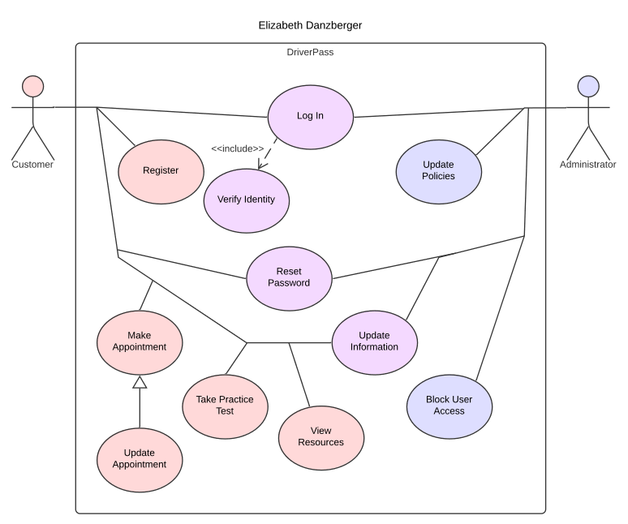

### UML Activity Diagrams

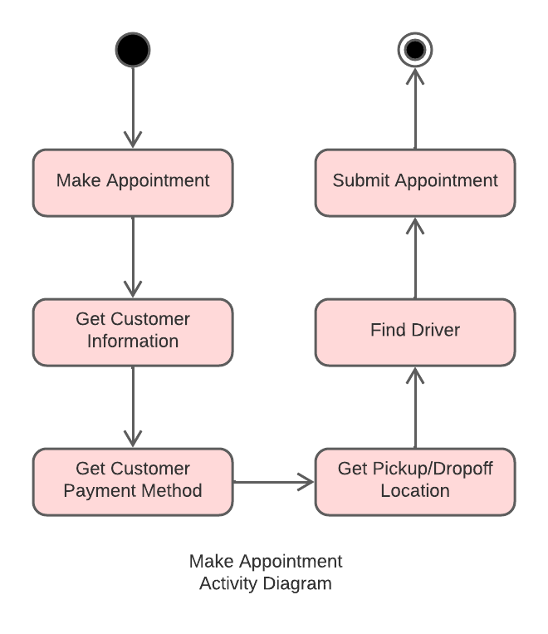

### 

### UML Sequence Diagram

### UML Class Diagram

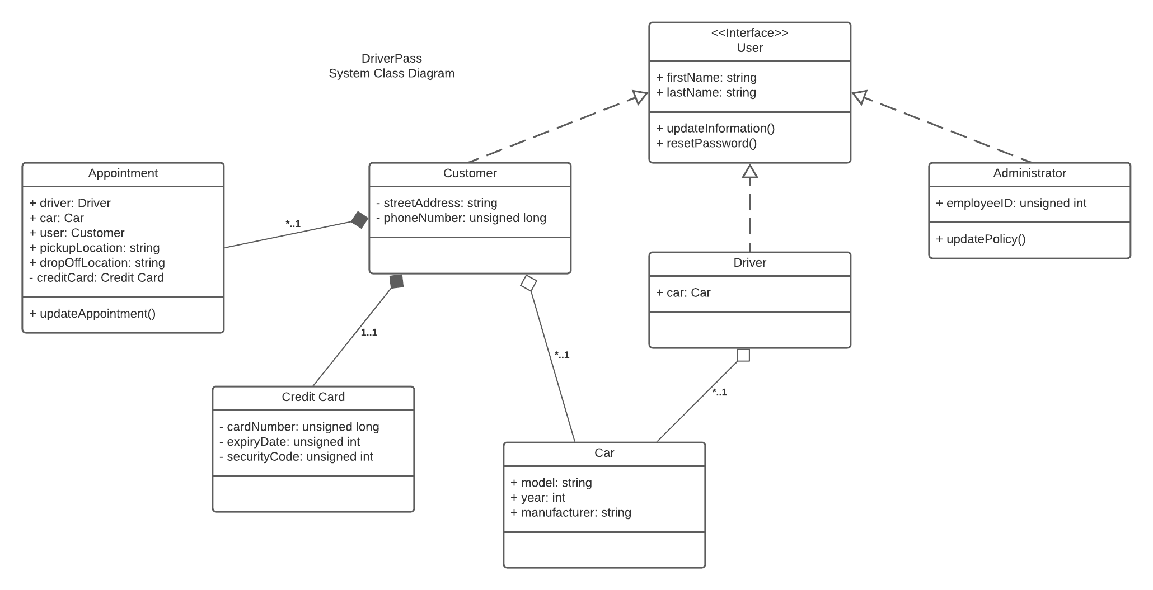

## Technical Requirements

The website shall run on a web server, hosted on a Linux machine, as Linux is free and easily scalable and customizable, meaning we can fit it to our needs and upgrade/downgrade hardware as necessary. The web server will also ideally host an API which the website can use to communicate with the server and various databases required to access customer information, appointment information, etc. The website shall be written using HTML5, CSS3, JavaScript, and use PHP and Python server-side. The web server shall support secure communication over HTTPS, and provide 2FA for security purposes and to abide by web-standards. MongoDB shall be used to manage and access databases. Because the website will be accessed from a variety of devices, the website must be optimized for every reasonable outcome. This includes responsive web design practices.